Power BI Dashboard Project Report: Return Risk Score Analysis

Introduction
This project aims to build a Power BI dashboard for analyzing product return behaviour in an e-commerce dataset. It identifies high-risk products with a greater chance of being returned by leveraging machine learning and visual analytics.

Abstract
Returns are a major concern in online retail, affecting profit margins, logistics, and customer satisfaction. This report outlines the development of a return risk score dashboard using Power BI, backed by Python-based return probability prediction. The result is an interactive dashboard that allows business users to explore key return patterns and identify high-risk products based on user behaviour, product category, and transaction attributes.

Tools Used
- Power BI Desktop – for interactive data visualization and dashboard creation
- Python (Pandas, Scikit-learn) – for data preprocessing and logistic regression modelling
- Jupyter Notebook – for developing and testing the machine learning model
- Excel (.xlsx) – for storing and importing cleaned datasets into Power BI

Steps Involved in Building the Project
- Data Preparation
  - Cleaned and loaded ecommerce_data.csv
  - Created a Return_Flag binary column (1 if returned, else 0)
  - Simulated return probabilities using logistic regression (for demonstration)
- Model Building in Python
  - Trained a logistic regression model to predict return probability
  - Added Return_Probability column to the dataset
  - Exported high-risk products (Return_Probability > 0.7) to a separate CSV
- Power BI Dashboard Development
  - Loaded the enriched Excel file into Power BI
  - Created KPIs: Total Orders, Return Rate, Avg Return Probability, High-Risk Orders
  - Used bar charts, pie charts, maps, and histogram visuals
  - Added slicers for Product Category, Gender, Location, and Shipping Method
  - Built a Drill-through Page for category-specific insights
- Export and Sharing
  - Published the dashboard for stakeholder review
  - Shared high-risk product CSV for further operational action
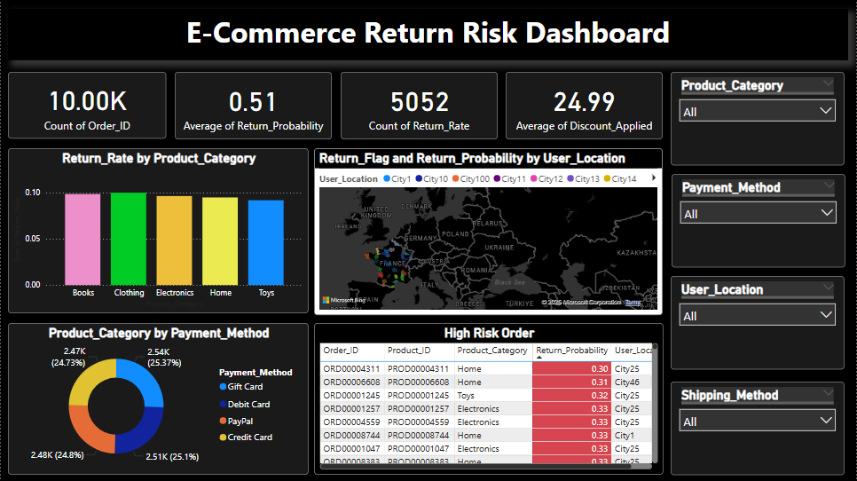

Conclusion
The Return Risk Score Dashboard successfully combines machine learning with business intelligence. It empowers decision-makers to track and understand return trends, pinpoint high-risk products, and take proactive steps to improve customer experience and reduce return rates. The use of drill-through filters and location-aware visuals enhances the interactivity and usability of the dashboard.

